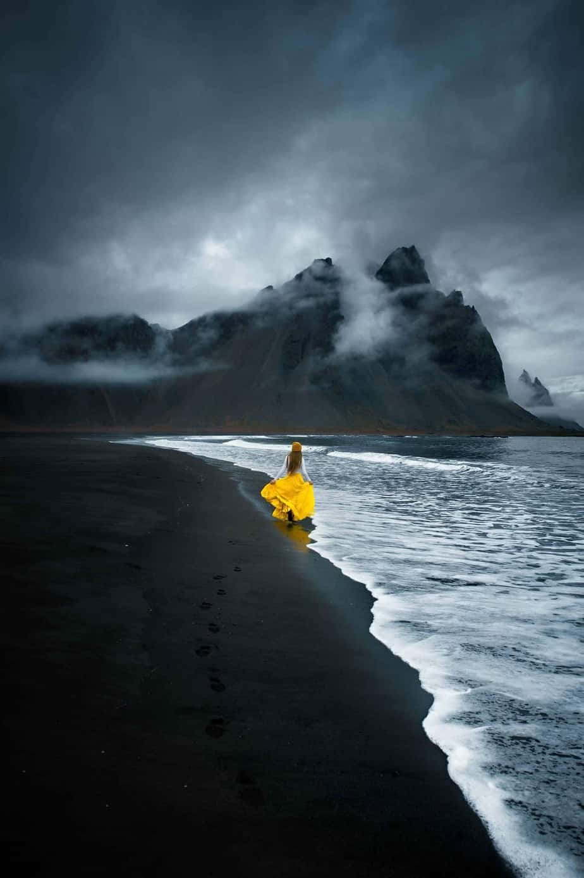***Iceland travel guide***

***“Land of fire and ice”***

2/3 of the population live in the capital Reykjavik

They build colourful buildings to help brighten the mood during the winter

The blue lagoon is easily accessed from the capital using public capital

Watch icelands 1000 year old geyser shoot bloiling hot water 30 meters in the air

Visit the boiling sands of black beach

The ring road is a national road in Iceland that circles the entire country. As a major trunk route, it is considered to be the most important peive of transport infrastructure in Iceland as it connects the majority of towns together in the most densely populated areas of the country